**Capstone Project – Choosing a neighborhood for a new ice cream shop in Manhattan**

**1. Introduction**

1.1 Problem Definition

I would like to open an ice cream shop in New York City. I need to choose the best location for my new venture. I believe that an ice cream shop will be better located if it is in a touristic zone and close to a large number of restaurants, cafés and bars. In order to choose the best location in Manhattan I will use the explore function from the Foursquare API to get the most common venue categories in each neighborhood, and then use this feature to group the neighborhoods into clusters. I will also use scatter plots to help me with my decision.

1.2 Interest

This methodology can be applicable to entrepreneurs who need to analyze geographic data to determine the location of a new enterprise.

**2. Data Acquisition**

2.1 Data Source

In order to analyze the neighborhoods and explore them, I will essentially need a dataset that contains all the boroughs and the neighborhoods in Manhattan as well as the latitude and longitude coordinates of each neighborhood. The dataset exists for free on the web: *https://geo.nyu.edu/catalog/nyu_2451_34572.*

In addition to the location of neighborhoods, information about commerce and places of interest is needed. For that, the Foursquare database will be used through the Foursquare API developer account.

2.2 Data Cleaning

My goal is to get a table with the location (latitude and longitude) of all neighborhoods in Manhattan containing the most common venues in each neighborhood. Therefore, only Manhattan will be analyzed, with all other boroughs discarded.

**3. Methodology**

From the table with the location and the most common venues in Manhattan, some criteria must be met to find the best location of the ice-cream shop:

* As the ice-cream shop must be located in a tourist area, the first, second or third most common venue in the neighborhood must be a hotel.
* The neighborhood should not contain an ice-cream shop among the most common venues.
* The ice-cream shop should be located in an area full of restaurants, bistros and cafes. That is, of the 10 most common venues, at least 6 must fall in the following categories: Restaurants, sandwich place, steakhouse, coffee shops, bakery, cafés and bistros.

**4. Results**

When selecting the 10 most common venues for each neighborhood in Manhattan, we obtain a table with 40 rows, as shown below.

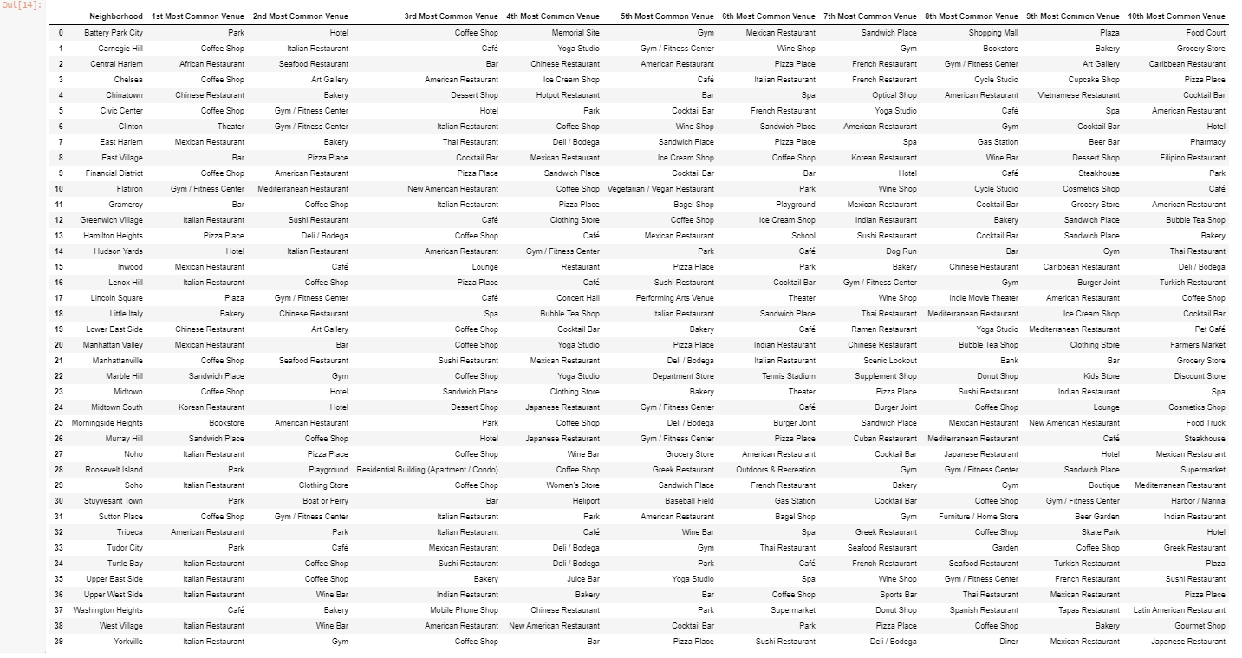

As the first criterion for choosing the location of the ice-cream shop is the proximity to a tourist area, the next step will be to filter the table above so that the first, second or third most common venue is a Hotel. The result is shown below.

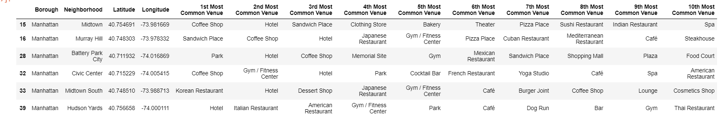

This filter reduced the possibilities to just 6 neighborhoods. It is important to note that none of them has an Ice-cream shop among the 10 most common venues, which was the next criterion to be analyzed.

The next step is to assess the concentration of restaurants, cafes, coffee shops, bakeries and bistros in each neighborhood. The criterion chosen for choosing the neighborhood of the new ice-cream shop is that at least 6 of the most common venues must be one of this type of establishment. We can see that only Murray Hill meets the criteria.

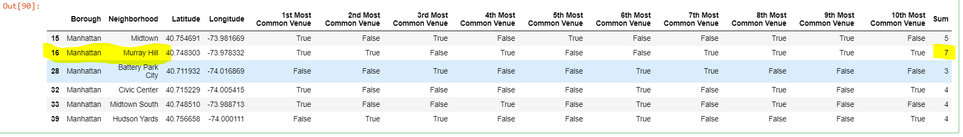

Let’s see where Murray Hill is in the map.

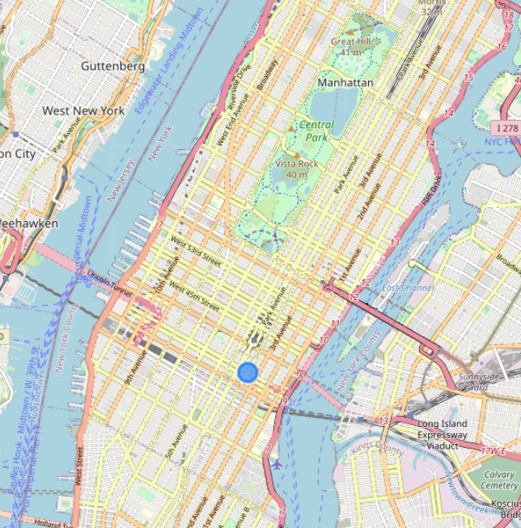

We can see that Murray Hill is in a very central location, in a walking distance to the Times Square and Central Park and full of restaurants, cafés , etc. Therefore, in terms of location, Murray Hill is the best place to a new ice-cream shop according to the methodology of this study.